On Android device you just have to connect to hotspot of Raspberry Pi and then captive portal will open from where you can download images and videos.

For IOS after connecting to hotspot, page on left image will open copy the URL and tap on cancel button on top right corner popup will open tap on **Use Without Internet** then open browser and paste URL to download images and videos

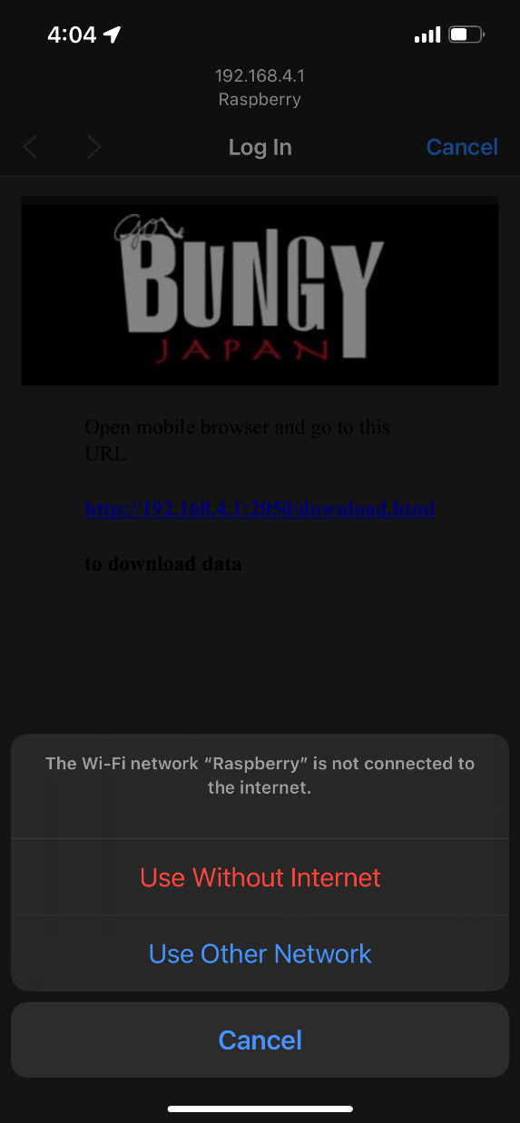 

If captive portal on IOS not opening make sure to enable this option and reconnect with hotspot.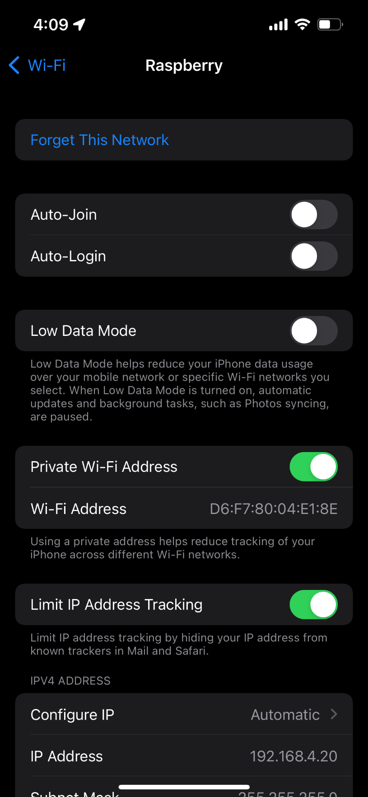



Default password of hotspot is **1a2b3c4d**

Before copying data from USB to RPi make sure your external device name is **UNTITLED**